Eman Fatima
HisabDo Internship
Day-06

10 Bug Reports
Note: There are no actual bugs found in DummyJSON so this is an observational bug reports.
Bug ID | Title | Severity | Priority | Status
BUG-001 | Authorization tab crashes in Postman ("Something went wrong") | Medium | Medium | Open
BUG-002 | Empty username returns generic validation message instead of field-specific error | Low | Low | Open
BUG-003 | Empty password returns generic validation message | Low | Low | Open
BUG-004 | Username with spaces returns "Invalid credentials" instead of validation error | Low | Low | Open
BUG-005 | Password with spaces returns generic error | Low | Low | Open
BUG-006 | API does not expose Registration endpoint for testing | Medium | Low | Open
BUG-007 | Logout endpoint not available | Medium | Low | Open
BUG-008 | Duplicate registration cannot be verified | Medium | Low | Open
BUG-009 | Invalid email format validation not available | Low | Low | Open
BUG-010 | Password policy validation endpoint unavailable | Low | Low | Open

Evidence:
Figure 1: Valid Login – 200 OK with Access Token
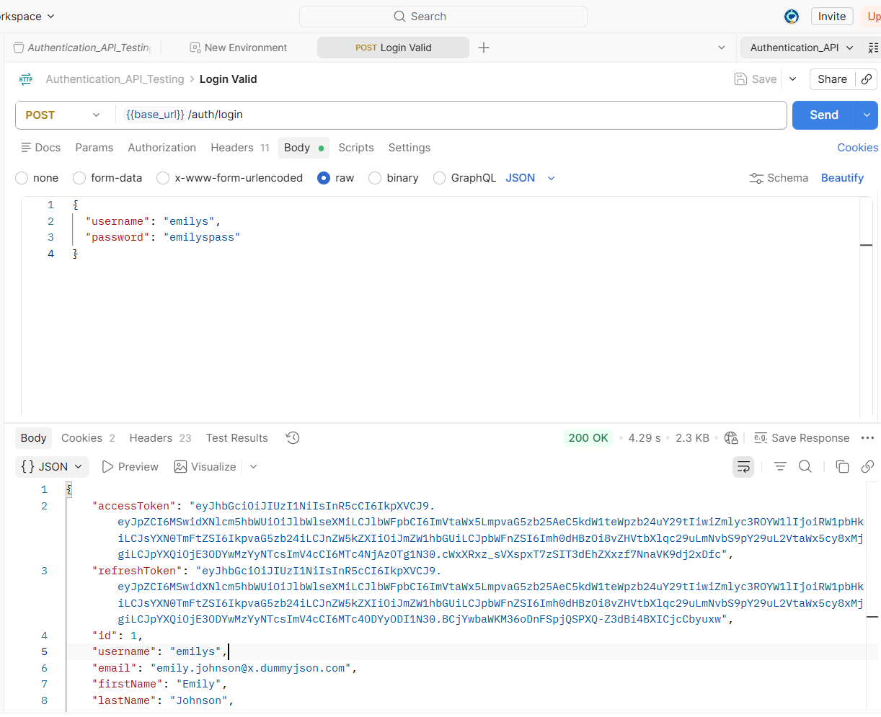
Figure 2: Invalid Login – 400 Bad Request (Invalid Credentials)
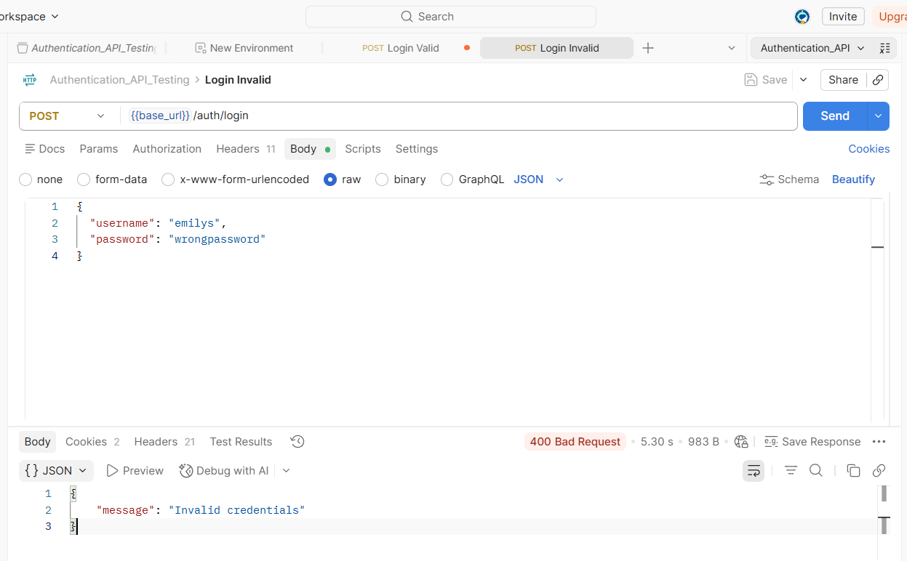

Figure 3: Empty Username – 400 Bad Request (Username and Password Required)
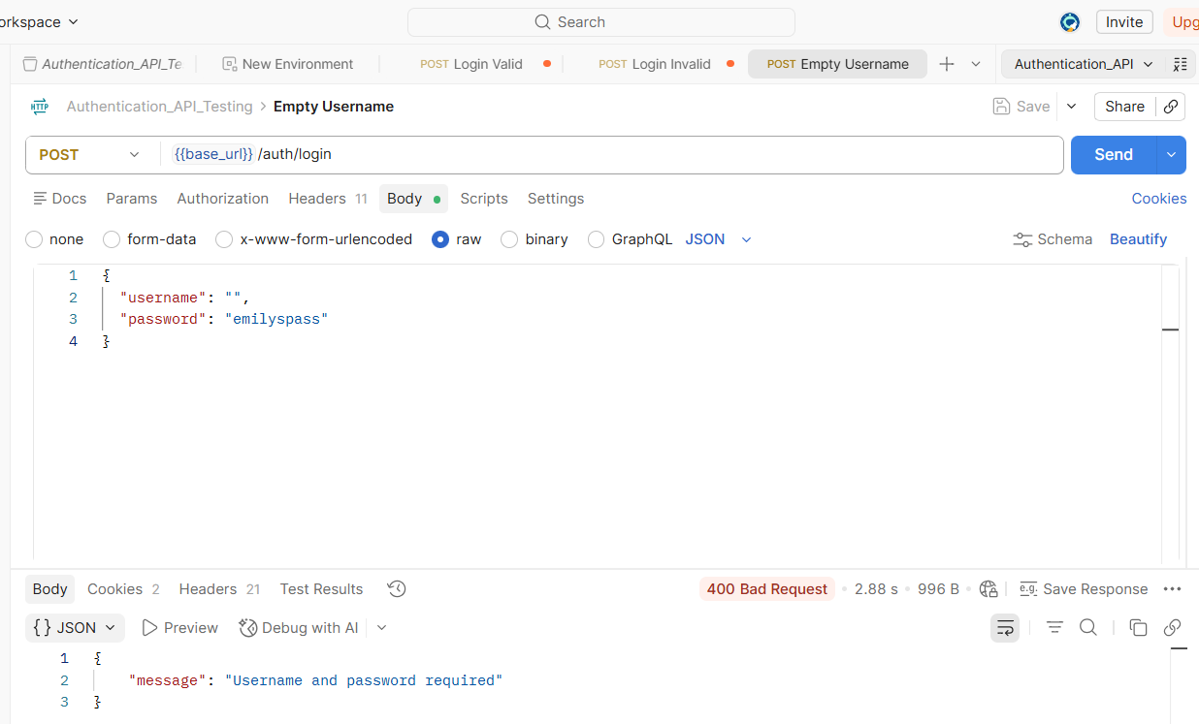
Figure 4: Empty Request Body – 400 Bad Request (Username and Password Required)
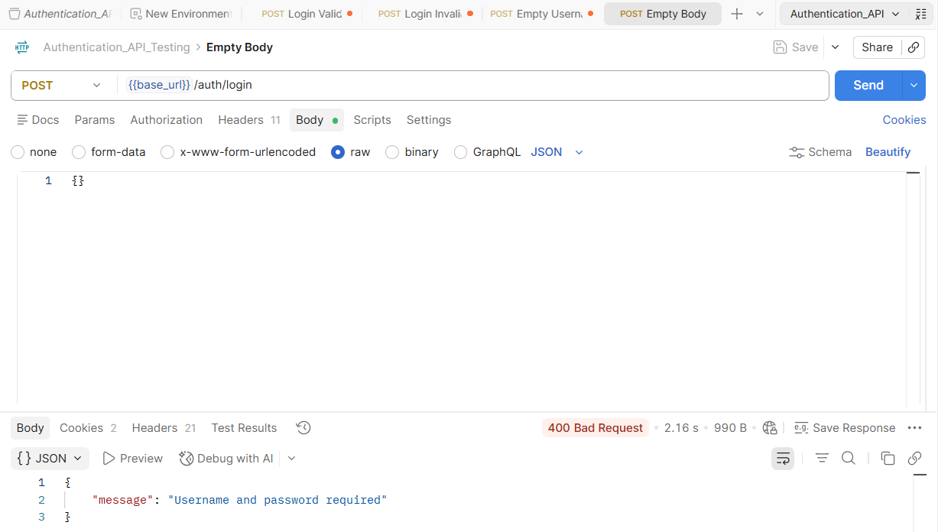
Figure 5: Missing Password – 400 Bad Request (Username and Password Required)
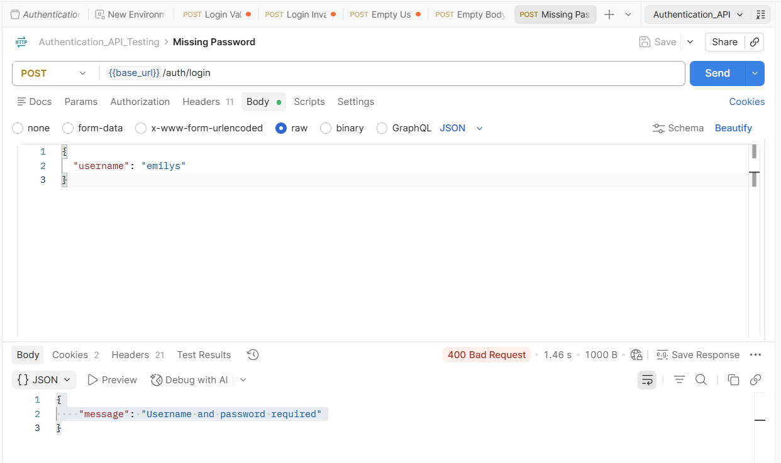
Figure 6: Missing Username – 400 Bad Request (Username and Password Required)
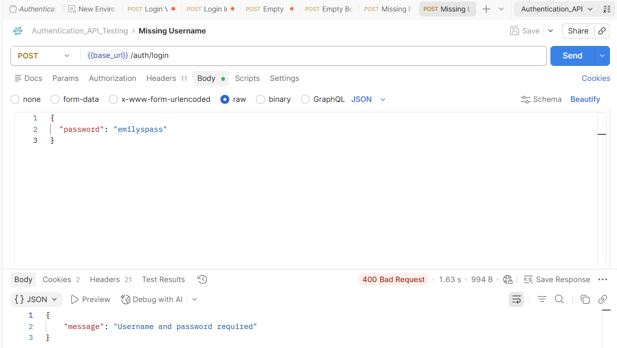

Figure 7: Wrong Username – 400 Bad Request (Invalid Credentials)
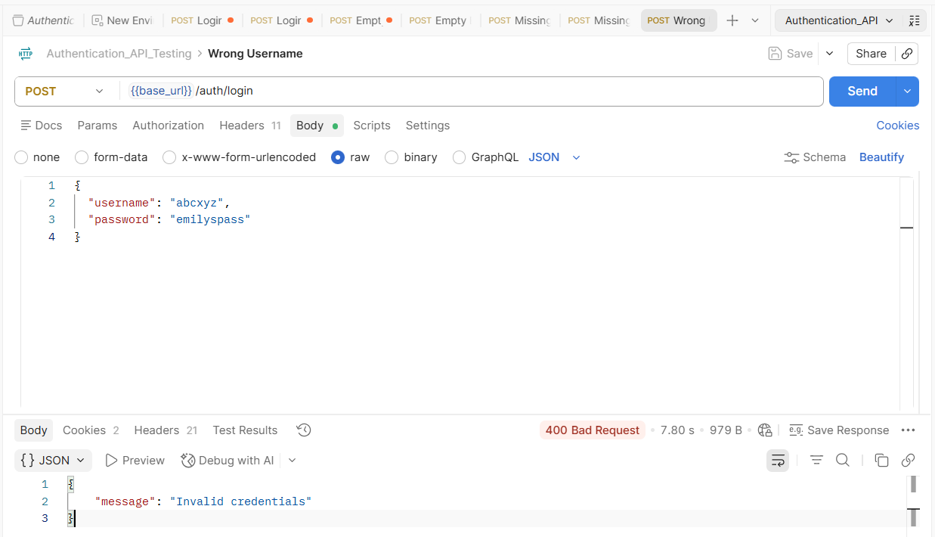
Figure 8: Wrong Username and Wrong Password – 400 Bad Request (Invalid Credentials)
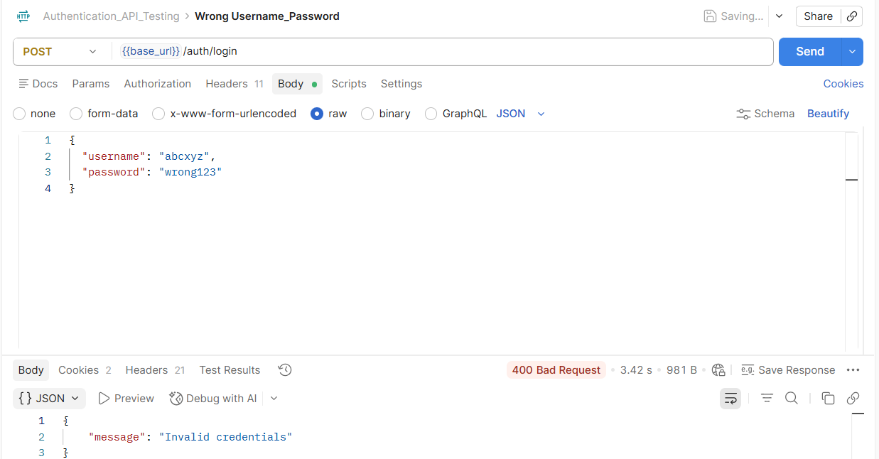

Figure 9: Username with Spaces – 400 Bad Request (Invalid Credentials)
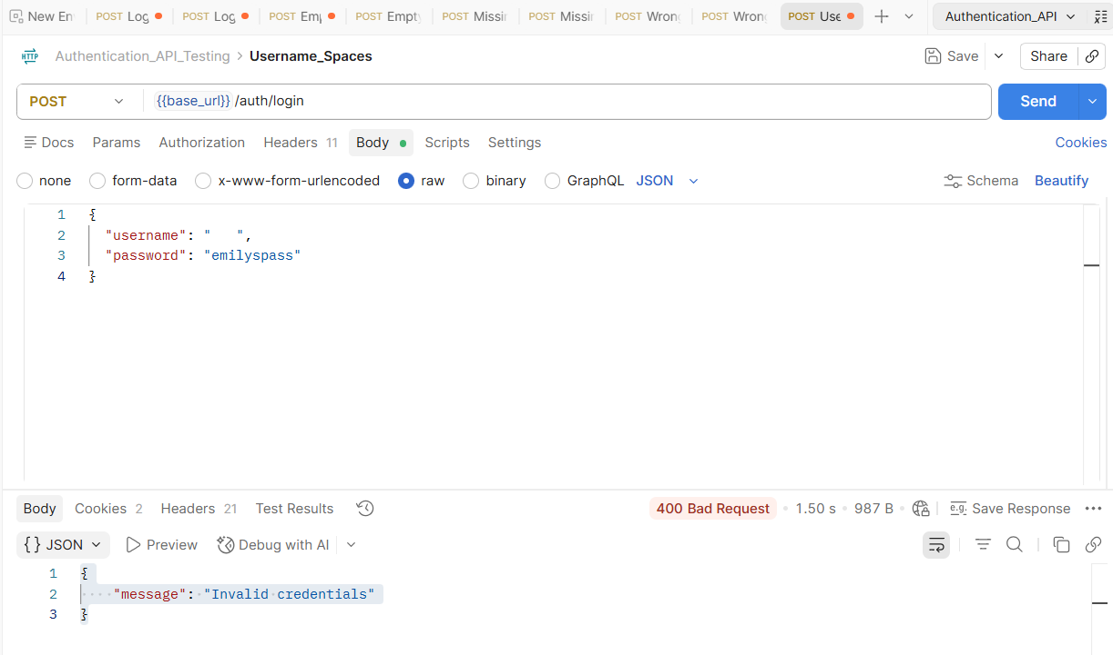
Figure 10: Password with Spaces – 400 Bad Request (Invalid Credentials)
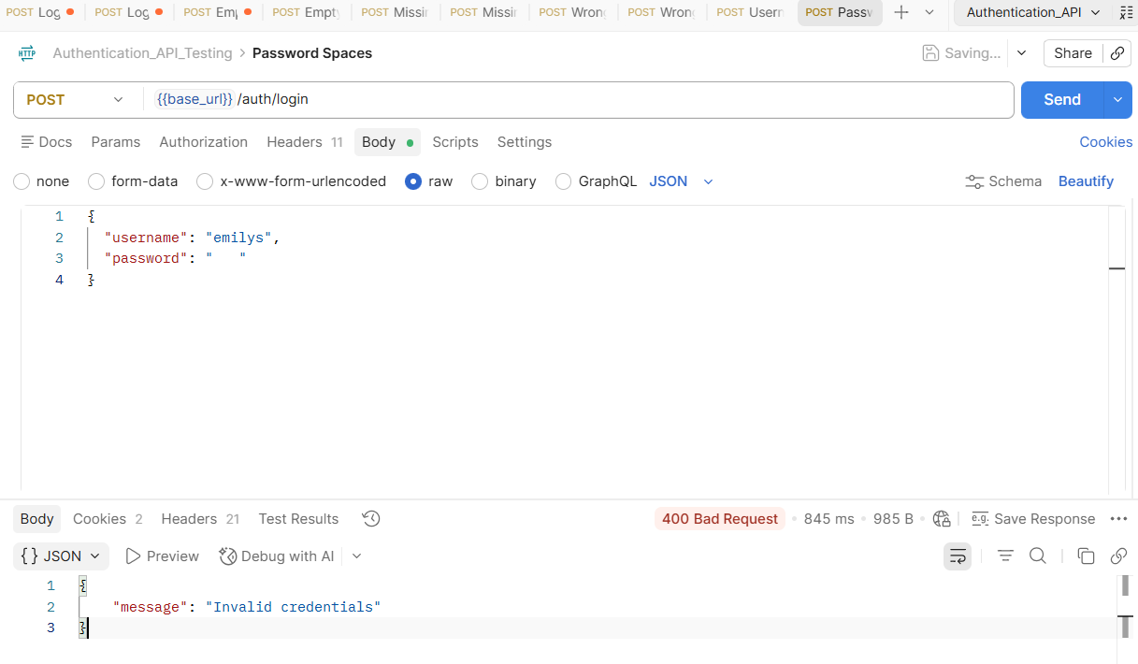
Figure 11: Unauthorized Access Without Token – 401 Unauthorized (Access Token is Required)
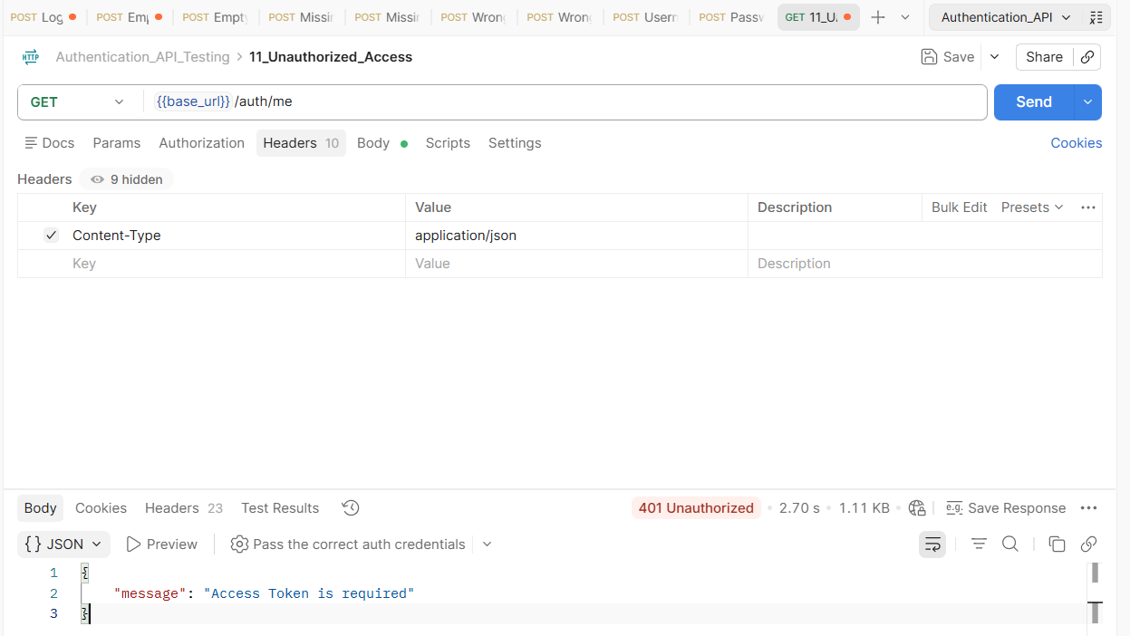

Test Summary Report

Authentication API Testing – Test Summary
Project: Authentication API Testing (DummyJSON)
Tool Used: Postman
API: DummyJSON Authentication API

Scope
- Login
- Invalid Login
- Missing Required Fields
- Unauthorized Access
- Token Validation

Test Execution Summary
- Total Test Cases: 30
- Executed: 11
- Passed: 11
- Failed: 0
- Blocked/Not Executed: 19 (Unsupported by public API)

Major Findings
- Valid login returned 200 OK with access token.
- Invalid credentials returned 400 Bad Request.
- Missing username/password returned proper validation message.
- Unauthorized access without token returned 401 Unauthorized.
- Token-based authentication worked as expected.
- Registration, Logout, Duplicate Registration and Password Policy endpoints were not available in the selected public API.

Conclusion
The authentication APIs available in DummyJSON behaved as expected. Login validation, authentication, and unauthorized access checks passed successfully. Some required internship modules could not be executed because the selected public API does not provide those endpoints.

